In This Topic

-LEONI KATA deployment.
-What is Kata?
-Why KATA & What is different about it?
- The 4 steps of Kata.

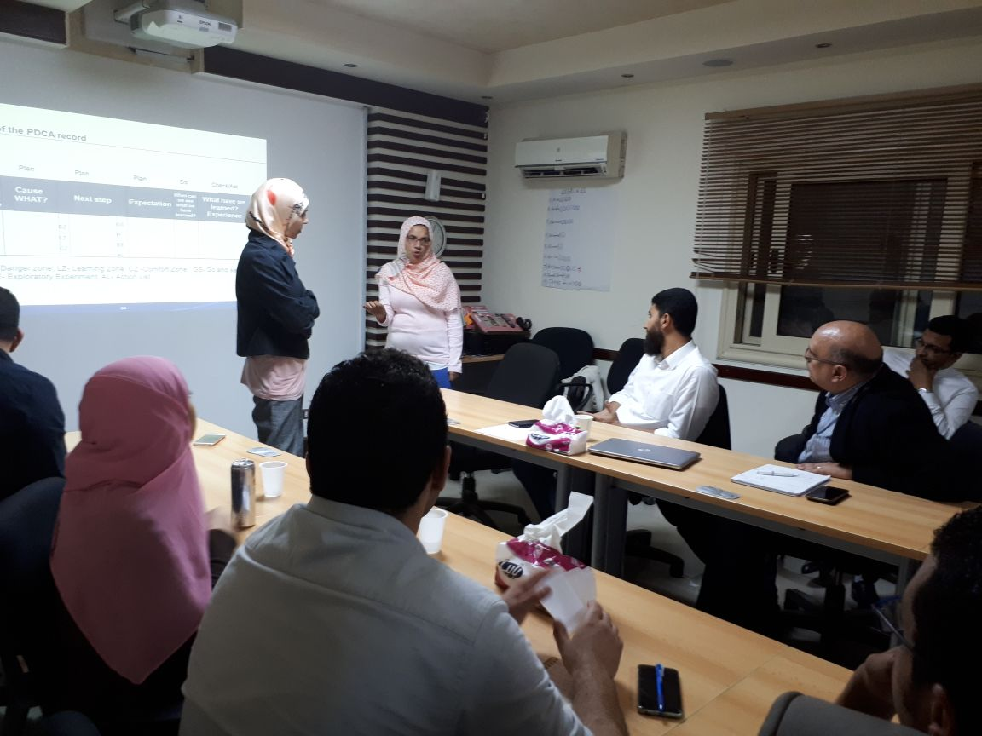
A lot of people have been wondering about how Leoni managed to implement the Kata tool successfully in their factories. Now the main target for most of the corporations is achieving KPIs, no matter how that will affect the employees and how stressful that can be and how it will affect their performance on the long term.

Leoni team chosen MS Zenab Sallam to share the success story of Leoni implementing the Kata and explaining how the Kata tool is used to achieve continuous improvement.
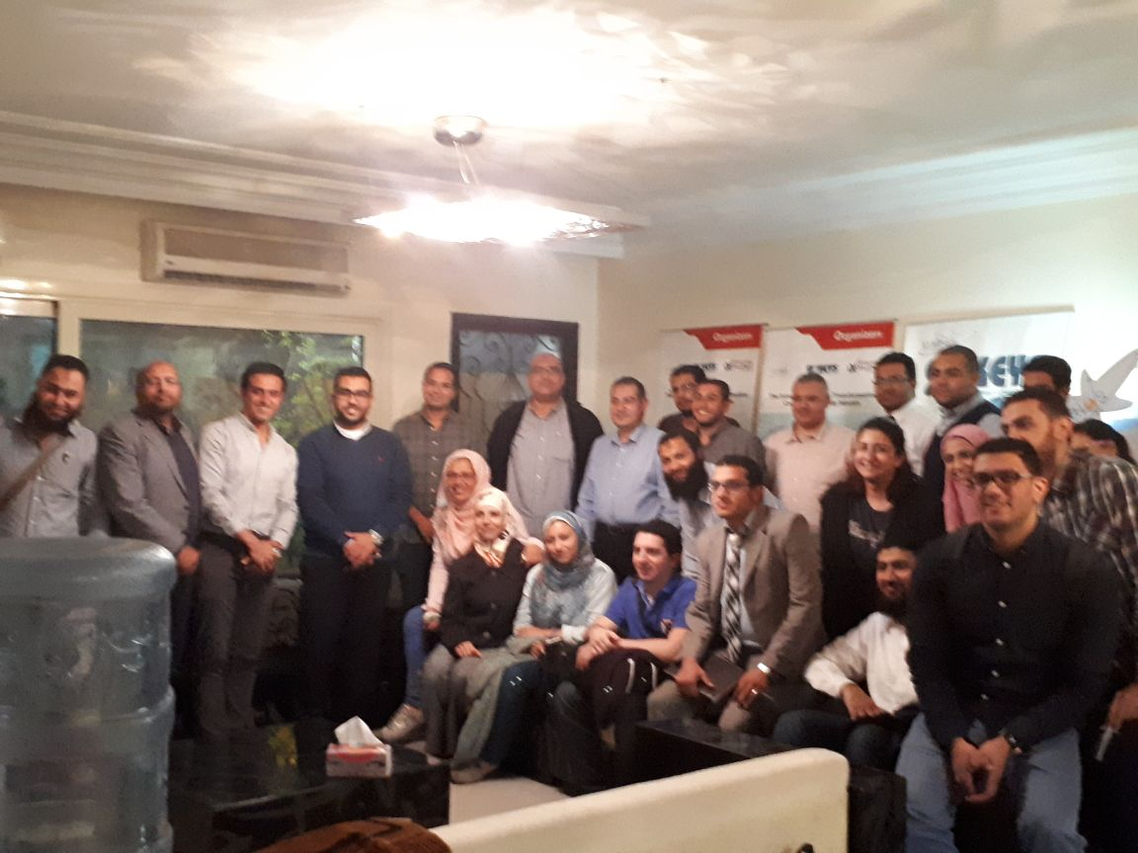
LEONI started the KATA deployment mid-2014, as a tool to create a sustained culture of continuous improvement.

In Kata approach a primary job of leaders and managers is to develop people so that desired results can be achieved. They do this by having the organization members (leaders and managers included) deliberately practice a routine, or Kata that develops and channels their creative abilities.

WHAT IS KATA?
The improvement kata is a routine for moving from the current situation to a target situation in a creative, directed, meaningful way.

IMPROVEMENT KATA AND COACHING KATA.
Improvement Kata is the part which the mentee works with the first coach to reach a standard behavior that helps develop the process daily.
Coaching Kata through the management coaching t to motivate and develop the mentees on daily basis.

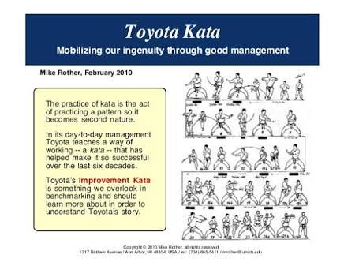
Improvement Kata: is a standard behavior for how to improve the process daily.
Coaching Kata: is a standard behavior for how to motivate & develop mentees daily.
Improvement Kata & Coaching Kata is a management routine that creates a culture, with an objective to build a system that develops people and processes scientifically.

Why KATA?
Because on the long term, and after addressing the big balls & quick wins, and in order to make sure that the continuous improvement process will be sustained, we need to get the involvement of everyone, creating a culture of continuous improvement. So it is the simple things, built on the Kaizen concept, small steps in a daily routine.

WHAT IS DIFFERENT ABOUT KATA?
Rather than just depending on management by KPIs, and to achieve better results, by improving the process, the KATA focuses on improving the skills & motivation of the employees, by improving the management coaching skills.
And the best way to keep the employees motivated is to give them new challenges that offers them the opportunity to develop their skills through learning by experience, and then achieving the self-satisfaction by new accomplishments that they weren’t sure that they have the capability to meet in the first place. 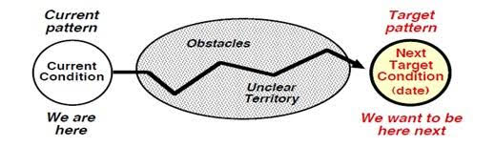
So instead of employees being just responsible to implement solutions where they don’t get to learn any thing. Now the management give them the trust and space to try and learn from their failure.

Going GEMBA “ the real place” is one of the most key strengths of the KATA, getting the management out of their offices & giving them the chance to understand more details about how their processes runs, and what challenges and obstacles do their employees meet..
Another key point is breaking down the overall challenges into smaller target conditions, assessing the current condition, then moving with small steps towards achieving the long term vision.

4 STEPS OF KATA:
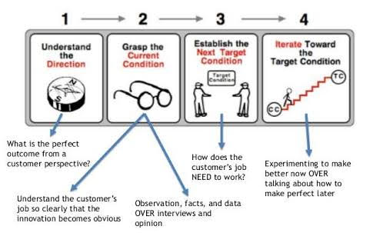
Aligned with the Vision the Challenge is set
Defining the long term vision and short term challenges by the management to make sure that all the improvement targets will be aligned.
The current condition is grasped with the process analysis
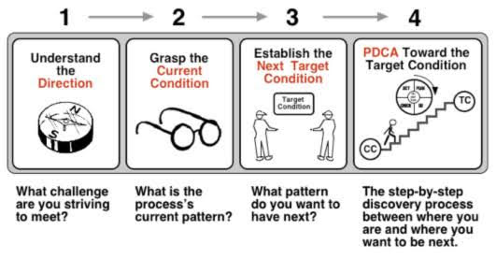
Assessing how the process is actually running using data analysis and process mapping.
And based on the current condition the target condition is developed
Based on the obstacles identified from the previous step, the mentee can set the target condition, and the coach job will be to make sure that the mentee have set the target out of his comfort zone to start his learning, development and increase his motivation.

The obstacles occurring will be treated with rapid PDCA cycles, with constant feedback from a coach, using the 5 questions.
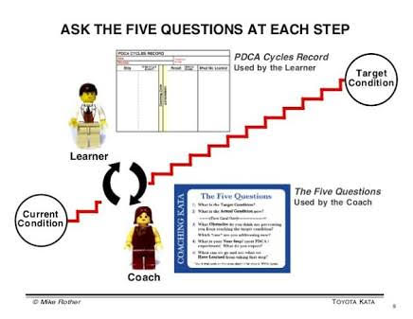
The discovery process between Current Condition and Target Condition by using the KATA daily PDCA cycle & the standard coaching dialogue.

